**Date: 28-10-2021**



**SOFTWARE DESIGN AND ARCHITECTURE**

**LAB 4 TASK**

**CLASS DIAGRAM**

**Question 1:**

Draw a class diagram for a scenario of a test system. The process flow is outlined below. Use association according to your own understanding

**i. Students attend Classes;**

**ii. Teachers mark attendance;**

**iii. Teachers prepare test papers;**

**iv. Students write test papers;**

**v. Teachers check test papers;**

**vi. Teachers declare results;**

**Answer:**

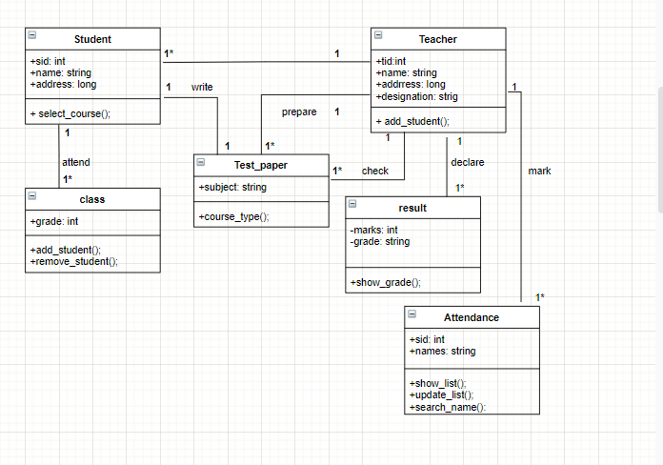

**Noun:**

* Student
* Name--- attribute of student
* Id—attribute of student
* Address--attribute of student
* Classes
* attendance
* Teacher
* Name-- attribute of teacher
* Id-- attribute of teacher
* Address-- attribute of teacher
* Designation-- attribute of teacher
* Teachers—redundant
* Test paper
* Test paper—redundant
* result

**Question 2:**

A company has a number of employees. The attributes of Employee include employee ID (primary key), name, address, and birth date. The company also has several projects. Attributes of Project include project ID, project name and start date. Each employee may be assigned to one or more projects, or may not be assigned to a project, a project must have at least one employee assigned, and it may have any number of employees assigned. As employee's billing rate may vary by project, and the company wishes to record the applicable billing rate for each employee when assigned to a particular project. At the end of each month, the company mails a check to each employee who has worked on a project during that month. The check amount is based on the billing rate and the hours logged for each project assigned to the employ

**Answer:**

**STEP 1:**

**Nouns:**

Company—irrelevant class

employee -- class

project---- class

billing_rate----class

employee_id-- attribute of employee

name: attribute of employee

address: attribute of employee

birth rate: attribute of employee

project_id: attribute of project

project_name: attribute of project

start date: attribute of project

employee—redundant class

project—redundant class

check_mail-- operation

**STEP 2:**

**Redundant classes:**

Employee

Project

**Attributes:**

* employee ID (primary key), name, address, and birth date for **class Employee**.
* project ID, project name and start date for **class project.**
* Hours_logged, project_type, project_date

**Operations:**

Check_mails(), record_billing_rate(), check_amount():

**Diagram:**

